**COAL Lab 01 Task**

**Name: Muhammad Shahbaz Hassan**

**Roll Number: 24K-0884**

**STEPS:**

1. **Create a new Visual C++ project name your ID K24_1234_COAL_Lab01 for Assembly Language.**

**Creating a new Project named K24_0884_COAL_Lab01**

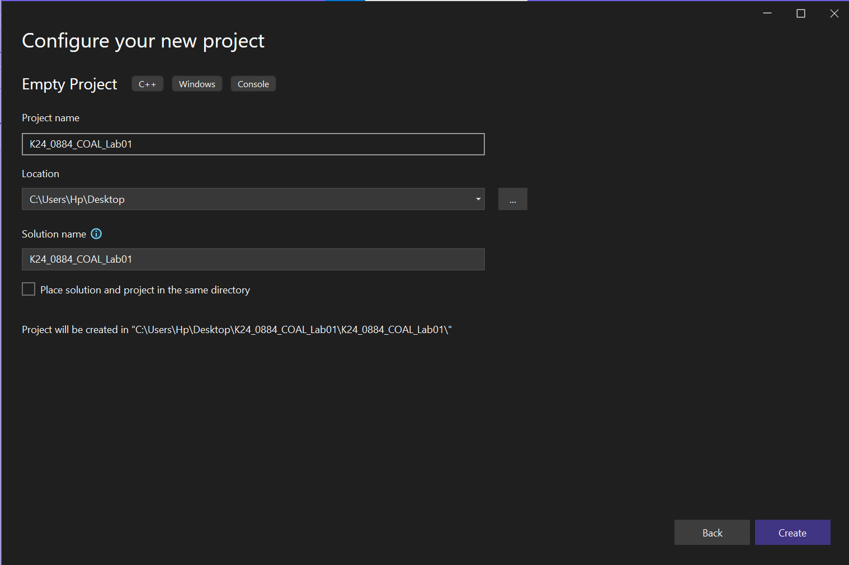

**2. Configure the project using the steps shown in this lab.**

**Creating Source.asm file**

**Setting Build Dependences**

**Setting Linker General Path**

**Setting Linker Input Path**

**Setting Microsoft Assembler type**

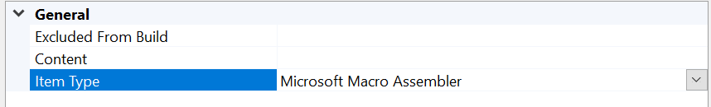

**Setting Microsoft Macro Assembler Path**

**3. Run Example 01 in console window by changing the value of EAX in line 5 to 8500h.**

**Writing Example 01 in Source.asm file**

**Running Example 01**

**4. Debug the below program and note down the values of all the registers after the execution of each  
line.**

**Writing the new Example in the Source.asm file**

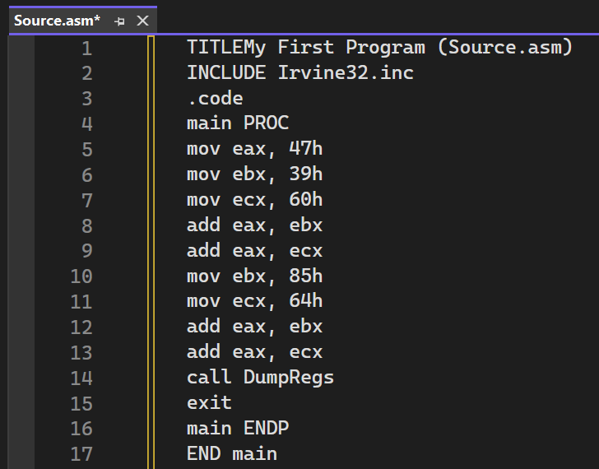

**Line 5 : mov eax, 47h**

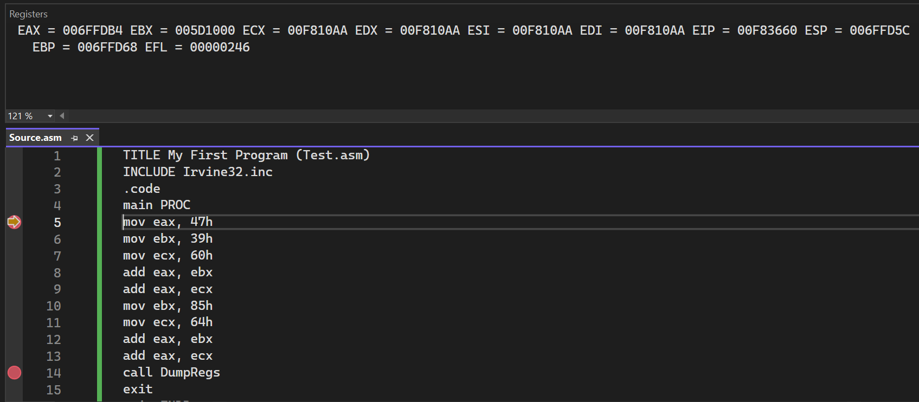

**Line 6 mov ebx, 39h**

**Line 7 mov ecx, 60h**

**Line 8 add eax, ebx**

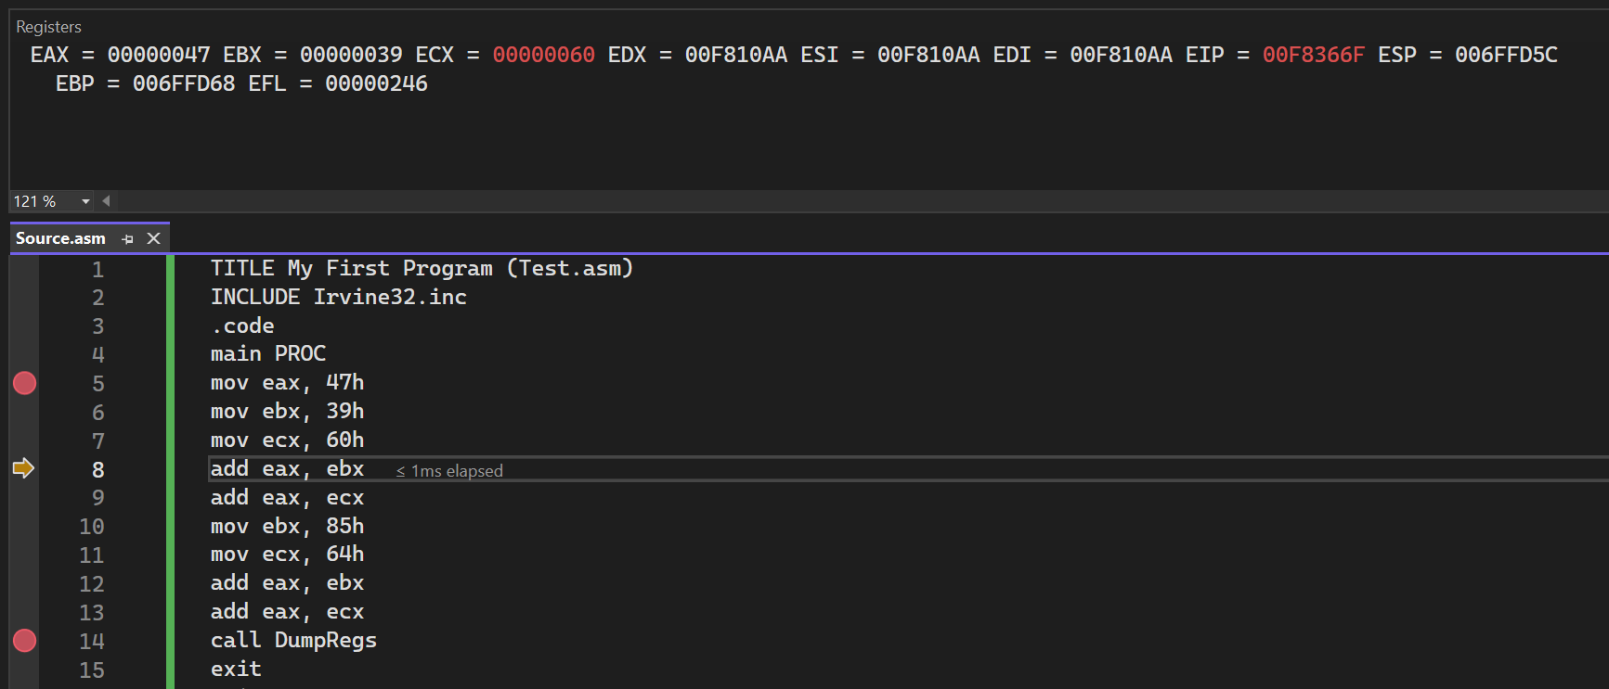

**Line 9 add eax, ecx**

**Line 10 mov ebx, 85h**

**Line 11 mov ecx, 64h**

**Line 12 add eax, ebx**

**Line 13 add eax, ecx**

**Line 14 call DumpRegs**

